YEAR | POPULATION | CHAIRPERSON | SUPERVISORS | CLERK | TREASURER
1840 | Portage County established in the Wisconsin Territory
1854 | 130 Voters | Thomas H McDill | Hiram Hartwell  Oliver Lamoreux | G.M.T. Parks | Eli Clarke
1893 | James Isherwood II – First Portage County Farmer to use a cream separator
1900 | 1,611
1920 | 1,399 | Moore Barn near Buena Vista Rd demolished – Skeletons found in floor!
1930 | 1,435
1939 | 1,761
1940 | 2,090
1947 |  | Thomas Kaczmarek | Mike Galecke  Ernest Rogers | Jay Phelps | Guy Carley
1949 |  | Thomas Kaczmarek | Mike Galecke  Merrill West  F Archibald* | Jay Phelps | Guy Carley
1950 | 1,621
1951 |  | Thomas Kaczmarek | Joseph Hamerski  Joseph Worzalla  Edward Sankey* | Jay Phelps | Guy Carley
1952 |  |  | George Cartmill*
1953 |  | J.N. Starr | Caroll Dakins  Mike Galecki | Jay Phelps | Guy Carley
1955 |  | Milvern Jacklin | Caroll Dakins  Edward Sankey | Cecil Allen | Guy Carley
1957 |  | Milvern Jacklin | Caroll Dakins  Edward Sankey | Cecil Allen | Guy Carley
1959 |  | Milvern Jacklin | Caroll Dakins  Edward Sankey | Cecil Allen | Guy Carley
1960 | 1,972 | Cecil Allen* | Roman Eickendorf* | Leland Bartsch*
1961 |  | Cecil Allen | Roman Eickendorf  Edward Sankey | Leland Bartsch | Guy Carley
1963 |  | Cecil Allen | Roman Eickendorf  Edward Sankey | Leland Bartsch | Fern Carley  Paul Thomasgard*
1965 |  | Gale West | Edward Sankey  Leonard Walkush | Frank Barnsdale | Paul Thomasgard
1967 |  | Peer Buck | Bernard Krueger  John Zuramski* | Frank Barnsdale | Paul Thomasgard
1969 |  | Cecil Allen | Carroll Dakins  Edward Sankey | Frank Barnsdale | Paul Thomasgard
1970 | 3,692
1971 | 3,740 | Cecil Allen | Dorr O’Brien  Edward Sankey | Frank Barnsdale | Paul Thomasgard
VILLAGE OF PLOVER INCORPORATED
1972 | 1,219 | Robert Steinke* | Gilbert Higgins*  George Sterling* | Florence Simmonds* | Rita Bannach*
Land Purchased from Gilbert and Ellen Higgins for Town Hall Location
1973 | 1,653 | Robert Steinke | Gilbert Higgins  George Sterling | Florence Simonds | Rita Bannach
1975 | 2,173 | Robert Steinke | Gilbert Higgins  Emil Pavelski | Florence Simonds | Rita Bannach
1977 | 2,290 | Robert Steinke | Gilbert Higgins  Emil Pavelski | Florence Simonds | Rita Bannach
1979 | 2,646 | Robert Steinke | Gilbert Higgins  Emil Pavelski | Florence Simonds  Margaret Walkush* | Rita Bannach
1980 | 2,330
1981 | 2,398 | Robert Steinke | Gilbert Higgins  Emil Pavelski | Margaret Walkush | Rita Bannach
1983 | 2,522 | Robert Steinke | Edward Mason  Emil Pavelski | Dorothy Pavelski | Rita Bannach
1985 |  | Robert Steinke | Jim Garbe  Don Jochman | Janice Beebot | Rita Bannach
1987 |  | Robert Steinke | Jim Garbe  Emil Pavelski | Janice Beebot | Rita Bannach
1989 |  | Robert Steinke | Jim Garbe  Emil Pavelski | Janice Beebot | Rita Bannach
1990 | 2,223
1991 |  | Robert Steinke | Don Jochman  Dale O’Brien | Cindy Simonds | Rita Bannach
1993 | 2,310 | Robert Steinke | Don Jochman  Dale O’Brien | Cindy Simonds | Rita Bannach
1995 |  | Robert Steinke | Don Jochman  Dale O’Brien | Cindy Simonds | Rita Bannach
1996 | Annexation of land and subdivisions north of Cty Hwy HH to Stevens Point – 10 year window
1997 | 2,333 | Robert Steinke | Don Jochman  Dale O’Brien | Cindy Simonds | Rita Bannach
1998 | 2,345 |  |  |  | Denice Bentley*
1999 | 2,415 | Robert Steinke | Don Jochman  Dale O’Brien | Cindy Simonds | Denice Bentley
Current Town Hall Built
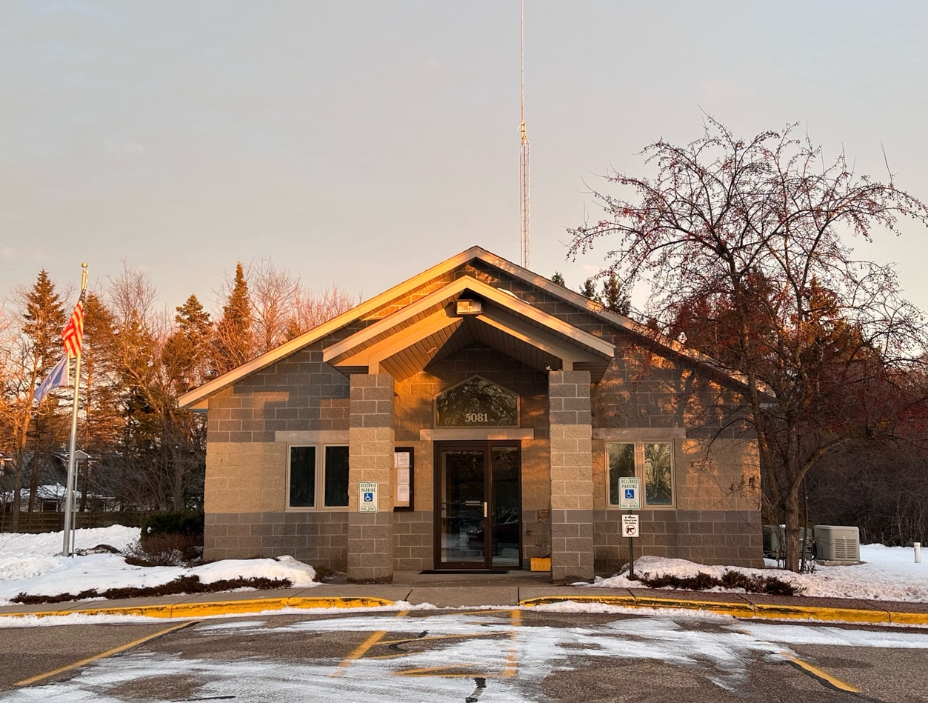
YEAR | POPULATION | CHAIRPERSON | SUPERVISORS | CLERK | TREASURER
2000 | 2,415
2001 |  | Robert Steinke | Jeanne Fehrman  Dale O’Brien | Cindy Simonds | Denice Bentley
2003 | 2,432 | Robert Steinke | Dale O’Brien  Lou Simonds | Cindy Simonds | Denice Bentley
2005 | 2,444 | Robert Steinke | Dale O’Brien  Lou Simonds | Cindy Simonds | Denice Bentley
2006 | Clerk and Treasurer Positions Combined
 |  |  |  | CLERK/TREASURER
2006 | 2,436 |  |  | Rhonda Pavelski*
2007 | 1,910 | Timothy Karcheski | Joe Firkus  Eugene Pavelski | Rhonda Pavelski
2007 | 10 Year Window of Annexations to Stevens Point Expires
2008 | 1,634 |  |  | Joan Scheider*
2009 | Beginning of Five Member Town Board – Terms are Staggered
2009 | 1,634 | Timothy Karcheski | Joe Firkus  Jim Isherwood  Dave Schaub  Bill Sniadajewski | Joan Scheider
2010 | 1,701 | Timothy Karcheski | Joe Firkus  Jim Isherwood  Dave Schaub  Bill Sniadajewski  Dale O’Brian* | Joan Scheider
2011 | 1,710 | Timothy Karcheski | Joe Firkus  Jim Rowe  Dave Schaub  Bill Sniadajewski | Joan Scheider
2012 | 1,710 | Timothy Karcheski | Joe Firkus  Jim Rowe  Dave Schaub  Bill Sniadajewski | Joan Scheider
2013 | 1,715 | Timothy Karcheski | Roger Bentley  Joe Firkus  Jim Garbe  Dustin Check* | Joan Scheider
2014 | 1,715 | Timothy Karcheski | Roger Bentley  Joe Firkus  Jim Garbe  Dustin Check* | Joan Scheider
2015 |  | Timothy Karcheski | Roger Bentley  Dustin Check  Joe Firkus  Jim Garbe  Mike Langlois  Jim Rowe* | Joan Scheider

YEAR | POPULATION | CHAIRPERSON | SUPERVISORS | CLERK/TREASURER
2016 |  | Timothy Karcheski | Joe Firkus  Jim Garbe  Mike Langlois  Jim Rowe | Joan Scheider
2017 |  | Timothy Karcheski | Joe Firkus  Jim Garbe  Mike Langlois  Jim Rowe | Joan Scheider
2018 |  | Timothy Karcheski | Joe Firkus  Jim Garbe  Dennis O’Brien  Bill Honaker* | Joan Scheider
2019 | 1,721 | Timothy Karcheski | Joe Firkus  Jim Garbe  Dennis O’Brien  Joan Scheider | Patricia Weller*
2020 | 1,742 | Timothy Karcheski | Joe Firkus  Jim Garbe  Dennis O’Brien  Joan Scheider  Richard Pingel* | Patricia Weller*
2021 | 1,744 | Timothy Karcheski | Joe Firkus  Jim Garbe  Deb Sniadajewski  Richard Pingel* | Patricia Weller
2022 | 1,752 | Jim Garbe* | Joe Firkus  Richard Pingel  Deb Sniadajewski  Roger Bentley* | Patricia Weller
2023 |  | Jim Garbe | Roger Bentley  Joe Firkus  Richard Pingel  Rex Rossier | Patricia Weller
2024 |  | Jim Garbe | Roger Bentley  Joe Firkus  Richard Pingel  Rex Rossier | Patricia Weller
2025 | 1,565 | Jim Garbe | Roger Bentley  Joe Firkus  Richard Pingel  Timothy Tuttle | Patricia Weller
*Appointed to the position mid-term
Elections for positions in the Town of Plover occur the first Tuesday in April. Officers are seated at the Annual Town Meeting which occurs the third Tuesday in April. The Chairperson, Clerk/Treasurer, and two of the four Supervisors are elected in odd-numbered years. The other two Supervisors are elected in even-numbered years.

